Architecture Centric Delivery

Architecture Definition
According to IBM, using RUP: A Software Architecture of a program or computing system is the structure or structures of the system, which comprise software elements, the externally visible properties of those elements, and the relationships among them. The software architecture of a system or a collection of systems consists of all the important design decisions about the software structures and the interactions between those structures that comprise the systems. Decisions made about software architecture support a desired set of qualities that the system should support to be successful, providing a conceptual basis for system development, support, and maintenance.

Overview
The purpose of the Architecture Centric Delivery is to describe practices that enable supporting system delivery within architectural overview of the system, different architectural views may be used to depict different aspects of the system. Architecture Centric Delivery is meant to assist the delivery team and processes necessary to capturing and conveying any significant architectural decisions.

Software Architecture and Key Fundamentals of an Agile Process
Several of the fundamental principles of an Agile development process are important to consider when developing the software architecture of the system. These key principles are
- Develop (and document) in an agile fashion
- Architecture centric and User Story centric
- Model visually
- Develop in an iterative fashion

Develop (and Document) in an Agile Fashion
In order to keep the software development process agile and not overburdened by excess documentation an Agile development process recommend that modeling activities be focused on 2 aspects of the system; the business domain, and the system architecture, it is these two aspects of the system that are the major source of complexity , and require the most attention. The steps taken to modeling and prototyping the business domain model in parallel are discussed in the "Business Domain Modeling Guidelines ".
The important point here is to note is that it is often overkill, and even wasteful to create detailed design documentation for every aspect of the system. Frequently, this type of extensive documentation is not even referred to by the people who would require it most, the application developers. A significant amount of work is required to keep this document up to date, so it increasingly becomes more and more irrelevant with time.
In order to keep system documentation both useful and relevant it should be focused clearly on architecturally significant aspects of the system, which leads to the next principal.

Architecture centric and User Story Centric
An important concept of the development process is that requirements are organized using descriptive behavior to tell how various actors may interact with the system. Other non-behavioral requirements are captured in the context of one or more of these User Stories. It is because of this reliance on scenario driven requirements that the process is said to be User Story centric.

The process is also said to be architecture centric because there is an emphasis on designing, developing, and testing the architecture before full-blown construction iterations begin. The focus of Discovery is to develop and validate an executable architecture prototype. Subsequent construction phase iterations may than reuse this architecture in a template driven development approach.
Architecture is developed and validated in Discovery by selecting a subset of functional requirements (User Stories) and realizing them with Architecture modeling activities. The proposed architecture is then validated through implementation and testing activities. By the end of Discovery a comprehensive software architecture document should have been documented, reviewed by the appropriate stakeholders, and validated with executable code that is able to operate under the appropriate nonfunctional requirements such as user load, availability, and security.
It is important to note that a combination of a robustly documented application architecture and documented business domain model validated by executable code is usually sufficient for most projects to initiate construction activities without the need to heavily document the remaining aspects of the system.

Model Visually
Even when using an agile approach, software/application architecture is an important concept to model/document. Another key principle of an Agile processes is that modeling be done visually. Visual representations of the system allow understanding at a higher level of abstraction than browsing through source code and other implementation artifacts. However, many aspects of system code are best left described in the system code.
UML is an excellent tool for diagramming models, and will probably be used for the majority of business model diagram efforts. The focus of diagrams should be to facilitate brainstorming, and not necessarily try to capture all aspects of the proposed architecture. Attempt to do so will create a model that overwhelm the reader with detail and lack meaning. Remember that the purpose of documenting any model is to convey knowledge to a particular audience, not to capture the detail of every relationship and field type. Models are not diagrams; rather diagrams are used to help communicate a model to a specific audience.
When designing significant components of software architecture during Discovery a good approach is to use modeling tools to create initial sketch/ blueprint of a proposed component and use this blueprint as a discussion piece with whoever is responsible for implementing the component. An even better approach is to have the developer participate in the design/modeling process. Only when an architecturally significant component has been implemented and validated should more comprehensive documentation begin.

Developing in an Iterative Fashion
An Agile development process recommends an approach where system architecture is modeled and documented, but is also continually refactored from information discovered during implementation activities. Discoveries made during implementation must be allowed to flow back into architecture and design documents. Documentation is both selective and geared towards illustrating architecturally significant components of the system.

In the Discovery phase architectural analysis is dedicated towards creating a conceptual model that partitions application responsibility, and refines the candidate architecture developed during the initiation phase. This is not focused on developing heavy documentation, but rather getting a high level overview of how the system will conceptually interact with itself and other systems. Key mechanism requirements (technology enablers) such as persistence, error handling and security are defined in candidate architecture.

Architecture Description
System Context
System Context Diagrams are diagrams used to define the system boundaries (i.e. system under discussion) and represent interactions between the system under discussion and external systems/interfaces. These diagrams usually picture the system at the center, with no details of its interior structure, surrounded by all of its interacting systems, environment and activities. Often, the System Context Diagram can be supplemented with Domain Driven Design interaction patterns (e.g. Anti-corruption layer). Below is an example of a system context diagram:
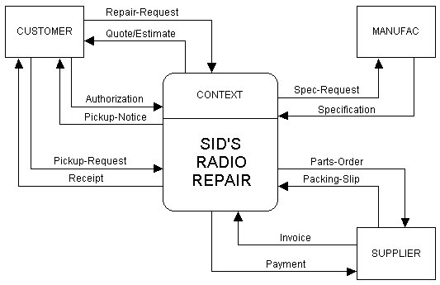
Platform Architecture
The platform architecture describes the software and application platforms that realize the architecture for the system. This view of the architecture communicates the technology choices and specific software packages/frameworks that will be used for developing the solution. Typically, a conceptual/logical architecture of capabilities is defined to guide the platform architecture that should be selected to meet the requirements of the overall solution capabilities.
Sample platform architecture for a multi-channel integration service:
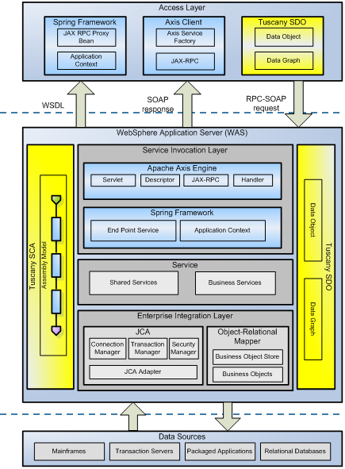
Layered Architecture
The purpose of this step is to organize the system architecture into layers and cohesive components. The number of layers is not fixed, but varies from situation to situation.
During architectural analysis, the focus is on modeling the application and business layers of the system. However if specific architectural patterns or reference architectures are used then they may also be incorporated into the model as well.
Sample layered architecture:
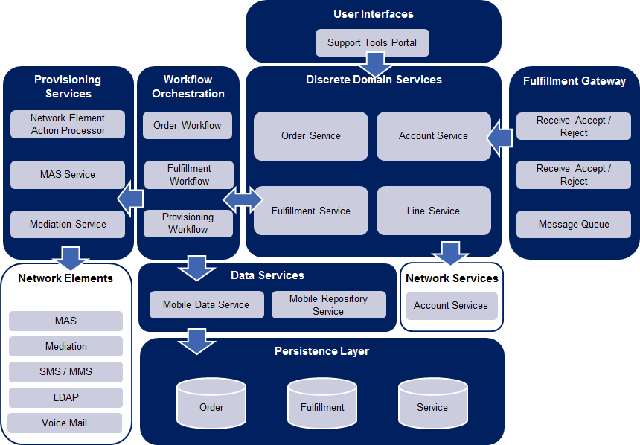
Deployment Architecture
Using a combination of deployment and or infrastructure diagrams, describe the deployment topology of the proposed solution.

Example:
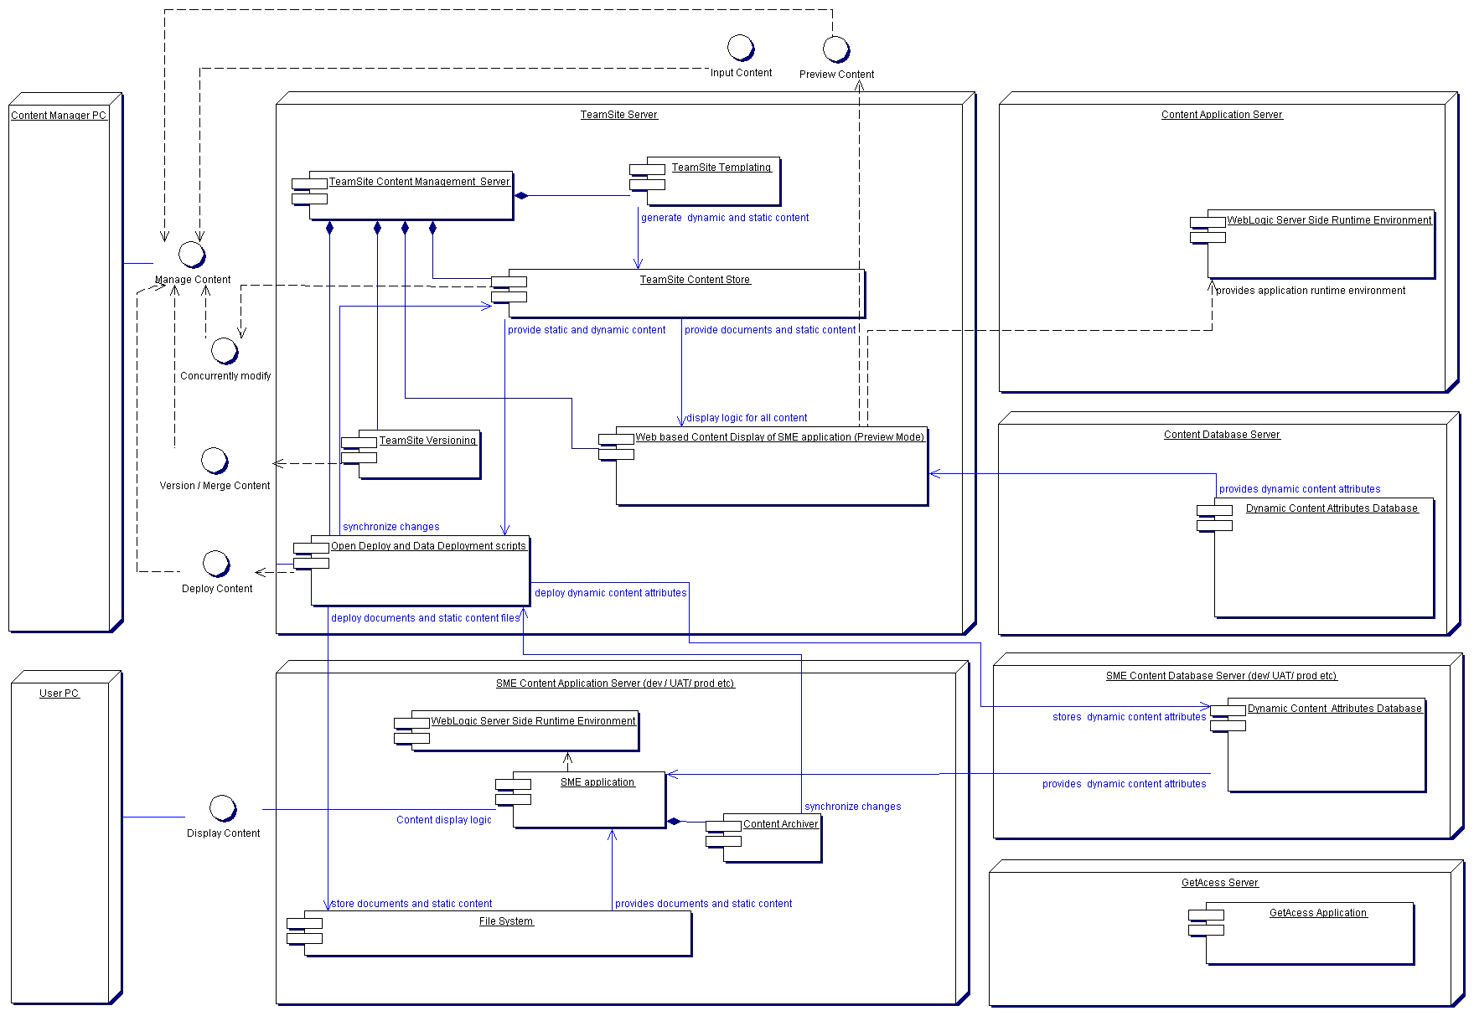

Architecture Risks
For complex systems, there is often significant risk that the architecture may not be technically feasible or meet the needs of the requirements upon implementation. Architecture centric delivery strives to mitigate these architecture risks by identifying them early in the project to inform the approach in addressing these risks. Common risks tend to fall into integration, performance, scalability, security or new unproven technologies. A number of strategies for mitigating these risks are available and include proof-of-concepts (POC), spikes, delaying irreversible decisions or applying set based thinking.
Architecture Constraints
Architecture constraints typically represent architecturally significant non-functional requirements that constrain the solution options. That means these requirements have a significant impact on the functional requirements themselves or solution. It is important to consider this category of requirements early on in the process to avoid making irreversible decisions in the solution and mitigating architecture risks. This category of requirements also often constrain the universe of features that the customer may want to a smaller set due to complexity, effort, time, risk and maintenance trade-offs. Examples of architecture constraints may be a requirement for 5 nines reliability or uptime (99.999%), response times of 1 second or less, or high security. As a result of these architecture constraints, a particular solution option may be a better choice than others.
Non-Functional Requirements
Unlike functional requirements, which define specific behavior or functions, non-functional requirements describe qualities of a system (what it is), and are requirements that specify criteria that can be used to judge the operation of a system, rather than specific behaviors. For example, a non-functional requirement of a system may be to have “sufficient network bandwidth”. Technical tests are often written to verify non-functional requirements.

Key Mechanisms
Key mechanisms are solutions to a common recurring problem within the system. Key mechanisms are recognized in terms of required functionality during the analysis phase internals will not be detailed. Common key mechanisms of this type include persistence, security and performance.
Key mechanisms can initially be grouped by type (example: persistent) and then by groups of clients that share a similar usage profile; identify a design mechanism based on each such need. These groupings provide an initial cut at the design mechanisms that will form the backbone of the architecture of the system. An example analysis mechanism, "inter-process communication", may map onto a design mechanism "object request broker". Different characteristic profiles will lead to different design mechanisms which emerge from the same analysis mechanism. The simple persistence mechanism in analysis will give rise to a number of persistence mechanisms.
The design of key mechanisms communicates how a key mechanism is realized in the solution. For example, the architecture may require a highly configurable and flexible engine to change and display a set of questions in a web form to end users. The key mechanism would be configurable questions for web forms and the design would describe the patterns and framework components to implement the configurable questions. The design in this scenario could be a database driven web form page with UI components that render based on data configured in the database by administrators through a web UI console. Typically, UML is used to communicate the design.

Key Mechanism Analysis
Key mechanisms are solutions to a common recurring problem within the system. Key mechanisms are recognized in terms of required functionality during the analysis phase internals will not be detailed. Common key mechanisms of this type include persistence, security and performance.
Example:
Persistence
Persistence key mechanism is used to facilitate reuse of persistence, or data access functionality across RiskRadar application components. Persistence mechanism encapsulates basic CRUD functionality for all RiskRadar entities that can be persisted. In addition, it encapsulates extended data-centric functionality as dictated by performance requirements.

Error Handling
The purpose of Error Handling key mechanism (implemented as RiskRadar error handling framework) is to enforce a uniform method of capturing application exceptions within RiskRadar web application as well as RiskRadar publishing process. Error handling framework defines the standard protocol for capturing both unexpected exceptions and application exceptions that result from business rules violations. Furthermore, the error handling framework defines the standard mechanism for displaying error messages to the end user – either in the real-time fashion format (in RiskRadar web application), or by persisting exception information to application log (in RiskRadar publishing process) – see definition of Logging key mechanism below.

Logging in
Logging key mechanism serves as a standard framework for logging various system messages, related to one of the following:
- Publishing process warnings and exceptions;
- Publishing process status messages;
- Publishing process activity execution metrics;
- web applications exceptions
Please note, that application is not logging user access to company and portfolio reports. Logging framework is not used for tracking usage patterns.

Security
Security mechanism encapsulates application-wide functionality related to user authentication and authorization. As such, this mechanism is used in the following scenarios and User Story realizations:

User Authentication
- User login – users accesses the RiskRadar application for the first time during a session and has to provide authentication credentials
- Since RiskRadar is a web application and as such is stateless, the application user is re-authenticated on each subsequent page visit using Intercepting Filter pattern.

User Authorization
Since the access to company information is restricted to authorized users only, User Authorization is invoked whenever RiskRadar user tries to access a company report. The following User Story realizations are impacted:
- Render Financial Report
- View Company Report

Key Mechanism Design
Building an initial modeling/documentation of the intended structure and interactions necessary to implement a specific key mechanism. Effort should focus on creating simple models that can be meaning, not on creating extensive formalized documentation.
- Context and Dependencies

Any dependencies in terms of third-party products or other aspects of the system are described using class/package diagrams.

Example:

- Participants

The application architect or designer will model an initial choice of the various classes and or other technical artifacts used by the key mechanism. One or more class diagrams are used to display key classes involved in the mechanism (to avoid confusion and promote clarity, non-essential classes are omitted from the diagrams). It is important to note that when designing key mechanisms a significant portion of the mechanism will be considered concrete, and have a fixed structure with fixed behavior. This is known as the base behavior of the mechanism. However, most key mechanisms, especially those based on frameworks, will also have pieces of the mechanism that must be extended in a specific way in order to be used. Examples of extensions include configuration files, abstract classes/interfaces, or placeholders for client code. Key mechanism extensions should be clearly identified using a different color from the rest of the participants of the mechanism.

Key mechanism components extensions are also referred to as parameter classes. Any client code that wishes to use this to mechanism must implement or modify each identified parameter class.
Example: abstract persistence mechanism

Figure 1 : Persistence & Manager Class Diagram

Interactive behavior

The software architect will then use a combination of collaboration, process, state and/or activity diagrams to illustrate the behavior of the key mechanism at runtime. The intention of this step is not to illustrate every single conceivable flow through the key mechanism, but rather to describe typical interactions between system participants that make up the key mechanism. It should be noted that the steps of defining the dependencies of the key mechanism, defining its participants, and defining its interactive behavior is an iterative process and information from one step will provide clarity to the next step.

Example:
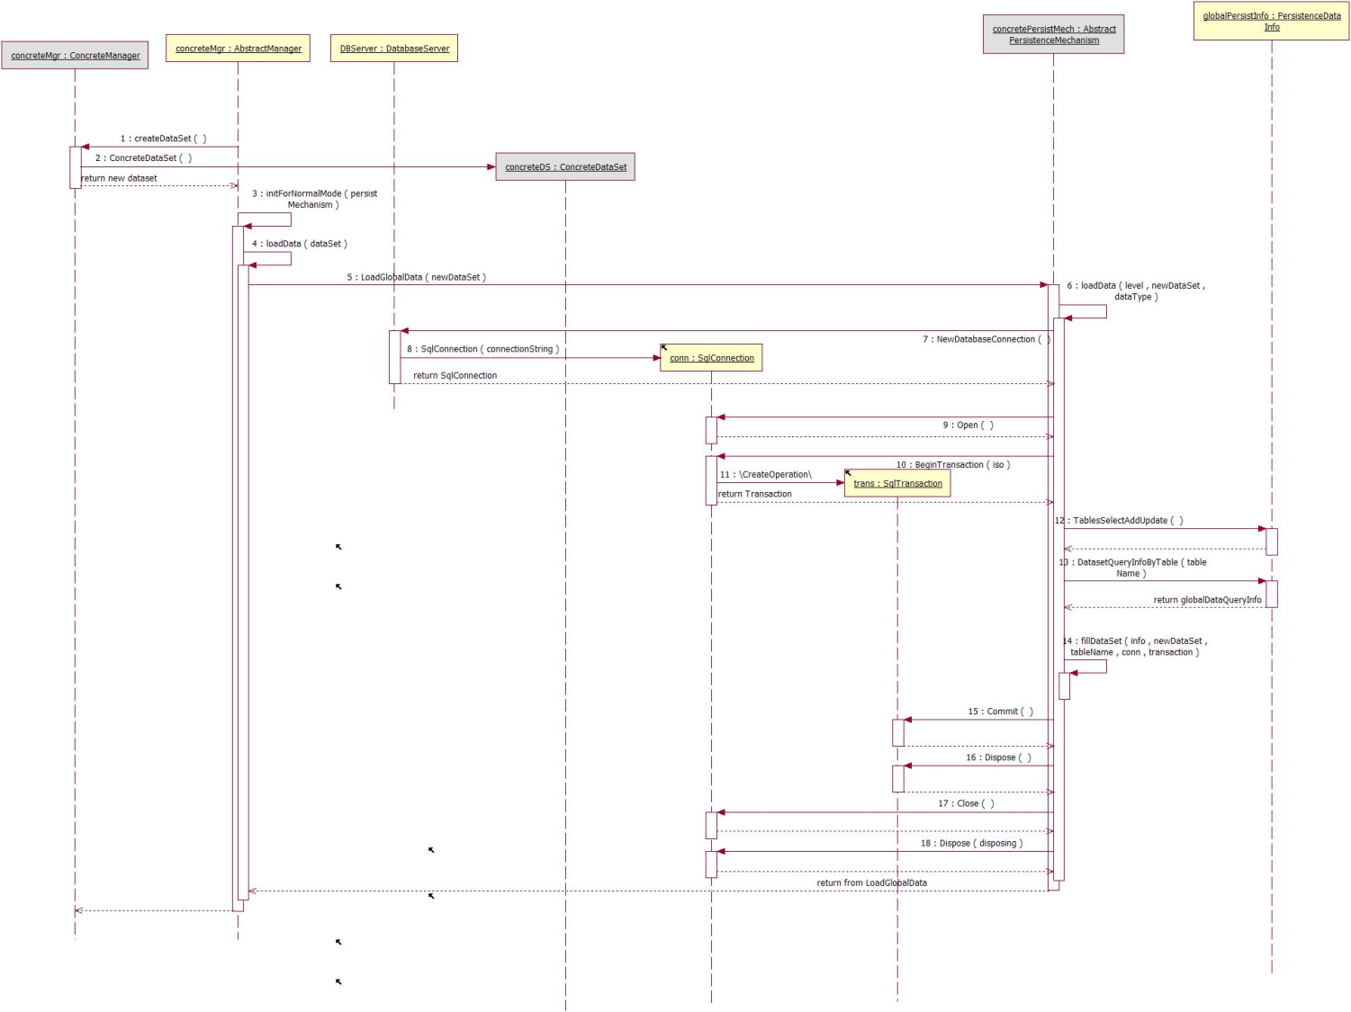

Integration and Reuse

Mark the boundaries and relationships between different models and/or systems in a specific project, program, or organization to determine appropriate integration strategies and identify components for sharing or reuse. This is achieved by defining a Bounded Context clearly illustrating the applicability of each model. A specific bounded context may span an entire system, a portion of a system, or across several systems within the enterprise. Once bounded contexts have been defined, a Context Map is created that gives a global overview of the relevant model/system contexts and the relationships between them. Once a Context is Bounded, meaning that all elements within the context will make use of the same model elements, Continuous Integration is used to keep the model unified. This will ensure that the project will not disrupt other projects or systems that share the same objects.

Model Boundaries (Bounded Contexts)

Multiple models coexist on big projects and each model applies in a context. The context of a particular model may be a certain part of the code, or the work of a particular team. The model context is whatever set of conditions must apply in order to be able to say that the terms in a model have a specific meaning. In order to establish model boundaries or a bounded context, the context within which the model applies must be explicitly defined. This can be achieved through activities such as a brainstorming session. Once the context is defined, explicitly set boundaries in terms of team organization, usage within specific parts of the application, and physical manifestations such as code bases and database schemas. Keep the model strictly consistent within these bounds and ensure that it is well documented and understood.

Example: Booking Context
A shipping company has an internal project to develop a new application for booking cargo. This application is to be driven by an object model. What is the bounded context within which this model applies? To answer this question, we have to look at what is happening on the project. This is a look at the project as it is, not as it ideally should be.
One project team is working on the booking application itself. They are not expected to modify the model objects, but the application they are building has to display and manipulate those objects. This team is a consumer of the model. The model is valid within the application (its primary consumer), and therefore the booking application is in bounds.
The completed bookings have to be passed to the legacy cargo-tracking system. A decision was made up front that the new model would depart from that of the legacy, so the legacy cargo-tracking system is outside the boundary. Necessary translation between the new model and the legacy is to be the responsibility of the legacy maintenance team. The translation mechanism is not driven by the model. It is not in the bounded context but is a part of the boundary itself. It is good that translation is out of context and not based on the model. It would be unrealistic to ask the legacy team to make any real use of the model because their primary work is out of context.

The team responsible for the model deals with the whole life cycle of each object, including persistence. Because this team has control of the database schema, they’ve been deliberately keeping the object-relational mapping straightforward. In other words, the schema is being driven by the model and therefore is in bounds.
Yet another team is working on a model and application for scheduling the voyages of the cargo ships. The scheduling and booking teams were initiated together, and both teams had intended to produce a single, unified system. The two teams have casually coordinated with each other, and they occasionally share objects, but they are not systematic about it. They are not working in the same bounded context. This is a risk, because they do not think of themselves as working on separate models. To the extent that they integrate, there will be problems unless they put in place processes to manage the situation. The first step, though, is to recognize the situation as it is. They are not in the same context and should stop trying to share code until some changes are made.
This bounded context is made up of all those aspects of the system that are driven by this particular model: the model objects, the database schema that persists the model objects, and the booking application. Two teams work primarily in this context: the modeling team and the application team. Information has to be exchanged with the legacy tracking system, and the legacy team has primary responsibility for the translation at this boundary, with cooperation from the modeling team. There is no clearly defined relationship between the booking model and the voyage schedule model, and defining that relationship should be one of the teams’ first actions. In the meantime, they should be very careful about sharing code or data.
So, what has been gained by defining this bounded context? For the teams working in context: clarity. Those two teams know they must stay consistent with one model. They make design decisions in that knowledge and watch for fractures. For the teams outside: freedom. They don’t have to walk in the gray zone, not using the same model, yet somehow feeling they should. But the most concrete gain in this particular case is probably realizing the risk of the informal sharing between the booking model team and the voyage schedule team. To avoid problems, they really need to decide on the cost/benefit trade-offs of sharing and put in processes to make it work. This won’t happen unless everyone understands where the bounds of the model contexts are.

In defining model contexts, elements of distinct models are sometimes combined. Combining elements of distinct models causes two categories of problems:

  - Duplicate Concepts mean that there are two model elements (and attendant implementations) that actually represent the same concept. Every time this information changes, it has to be updated in two places with conversions. On top of that, the team members must learn not one but two ways of doing the same thing, along with all the ways they are being synchronized.

  - False Cognates may be slightly less common, but more harmful. This is the case when two people who are using the same term (or implemented object) think they are talking about the same thing, but really are not. Conflicts can be subtle when the two definitions are actually related to the same aspect in the domain, but have been conceptualized in slightly different ways. False cognates lead to development teams that step on each other’s code, databases that have weird contradictions, and confusion in the communication within the team.

If these problems are detected, a decision will need to be made on whether to pull the model back together to prevent fragmentation or let the groups develop independently.

Continuous Integration Strategy

When a number of people are working in the same bounded context, there is a strong tendency for the model to fragment. It is very hard to maintain the level of communication needed to develop a unified system of any size. Methods are needed to increase communication and reduce complexity. Continuous integration means that all work within the context is being merged and made consistent frequently enough that when splinters happen they are caught and corrected quickly. Continuous integration operates at two levels: Integration of model concepts via constant communication among team members and Integration of the implementation through implementation artifacts that are integrated by a systematic merge/build/test process that exposes issues early. Many processes for integration are used, but most of the effective ones share these characteristics:

  - A step-by-step, reproducible merge/build technique;
  - Automated test suites; and
  - Rules that set some reasonably small upper limit on the lifetime of unintegrated changes.

Continuous integration is essential only within a bounded context and should be applied within any individual bounded context that is larger than a two-person task.

Important:

Institute a process of merging all implementation artifacts frequently, with automated tests to flag fragmentation quickly. Continuously ensure that a shared view of the model is understood by all parties as the model concepts evolve. For more information on continuous integration see the following sites:

Relationships Between Bounded Contexts
An individual bounded context still does not provide a global view. The context of other models may still be vague and in flux. People on other teams won’t be very aware of the context bounds and will unknowingly make changes that blur the edges or complicate the interconnections. Confusion can be reduced by defining the relationship between the different contexts and creating a global view of all the model contexts on the project. Relationships can be defined using a context map. To create a context map follow these steps:
- Identify each model in play on the project and define its bounded context
- Name each bounded context and include the names in the ubiquitous language of the business domain model
- Describe the points of contact between the models, outlining explicit translation for any communication

Example:

The relationships between bounded contexts take many forms depending on both design issues and project organizational issues. The following patterns cover a range of strategies for relating two models that can be composed to encompass an entire enterprise:

- Shared kernel: When functional integration is limited, the overhead of continuous integration may be too high. Separate bounded contexts may be defined and multiple teams formed. In this case, designate some subset of the domain model that the two teams agree to share. This includes, along with this subset of the model, the subset of code or of the database design associated with that part of the model. The shared subset should not be changed without consultation with the other team.

Diagram:

- Customer/supplier development teams: Often one subsystem essentially feeds another and all the dependencies go one way. In this case, establish a clear customer/supplier relationship between the two teams. Make the dependant team play the customer role to the team it relies on. Negotiate and budget tasks for dependant team requirements so that everyone understands the commitment and schedule. Jointly develop automated acceptance tests that will validate the interface expected. Ensure that both teams use these tests as part of their own continuous integration.
- Conformist: The customer/supplier development teams pattern will not work in certain situations such as when the two teams are in different companies or very far apart in the management hierarchy. In the case where the model style for both teams is of good quality and reasonably comparable it may be best to give up on an independent model altogether. In this situation, the dependant team adheres to the model of the team upon which they depend. This may not yield the ideal model for the application but greatly simplifies integration. The conformist pattern is often appropriate when delivering an enterprise package solution (e.g. PeopleSoft, SAP) that requires a slight or moderate customization/configuration.
- Anticorruption layer: When a new system is being built that must have a large interface with another, the difficulty of relating the two models can eventually overwhelm the intent of the new model altogether, causing it to be modified to resemble the other system’s model, in an ad hoc fashion. In this case, create an isolation layer to provide clients with functionality in terms of their own domain model. The layer talks to the other system through its existing interface, requiring little or no modification to the other system. Internally, the layer translates in both directions as necessary between the two models.

Diagram:

- Separate ways: Integration is always expensive and sometimes the benefits are small. In many circumstances, integration provides no significant benefit and may not be necessary. In this case, declare a bounded context to have no connection to the others at all, allowing developers to find simple, specialized solutions within this small scope.
- Open host services: When a subsystem has to be integrated with many others, customizing a translator for each can bog down the team. In this case, define a protocol that gives access to the subsystem as a set of services. Open the protocol so that all who need to integrate with the subsystem can use it. Enhance and expand the protocol to handle new requirements as necessary.
- Published language: Direct translation to and from the existing domain models may not be a good solution. Those models may be overly complex or poorly factored. In this case, use a well documented shared language that can express the necessary domain information as a common medium of communication, translating as necessary into and out of that language.
Diagram: Relative demands of each pattern

In order to choose the right relationship, it is important to draw the context map to reflect the current situation at any given time. Once the context map is created it is possible to further define context boundaries and relationships. Some things to consider when choosing boundaries and relationships are:
- Larger versus smaller: There are benefits to employing a few larger bounded contexts or more smaller bounded contexts. Larger bounded contexts can help the flow between user tasks become smoother, make the model more coherent, and foster more communication. Smaller bounded contexts can reduce communication overhead, keep the model less abstract, and can be catered to special needs. Choosing the appropriate size for bounded contexts based on the situation.
- Relationships with external systems: When dealing with external systems, three of the above mentioned patterns apply: Separate ways, Conformist and Anticorruption Layer. If integration is not required then choosing to go Separate ways is the best option. If integration is required, then depending on the situation choose the Conformist, Anticorruption Layer, Open Host Services or Published Language patterns based on the situation.
- Relationships within one system: As a team grows larger, continuous integration can become more difficult. Make sure to recognize new developments within the system under design and implement patterns accordingly. For example, creating a shared kernel or setting up a customer/supplier development team relationship. Another example would be to let two models go their separate ways if it has been determined that they clash. A good rule of thumb is to limit a bounded context around teams of no greater then 10 people.
- Transforming relationships: There will be cases where the initial decisions about the boundaries and relationships between bounded contexts will change. Merging or changing the relationships between bounded contexts can be difficult. When conducting such changes, ensure that the current situation is fully understood, the end result is clearly defined and there are processes in place to execute the transformation.

Example: Digital Cargo File

The context map below depicts the situation in the Digital Cargo File project, with the project responsibilities on the right hand side of the figure.

Context map – Digital Cargo File

The Model Contexts
On the left side of the context map we find three existing contexts: Supply Operation - supporting delivery of cargo, Invoice and Trading - supporting sales of cargos. These three contexts exist inside different legacy systems that must be integrated with Digital Cargo File.
In the middle we find the Communication Gateway, enabling the business to send and receive email, fax and telex. The end-user is represented to illustrate the fact that humans must operate the communication gateway directly for the purpose of manual sending and filing of business messages, and filing of inbound messages from counterparties. This operation is known as document control.
On the right side we find the Digital Cargo File (DCF) with its three distinct model contexts: Front Page providing the cover page of a physical folder – used for content follow-up and case management, Folder providing the logical storage model and Document Storage defining the physical document storage model.
At the bottom we find Shipment & Allocation supporting oil field operation and owner allocation of produced volumes to be deployed for production in 2006.
Context Map Analysis
With the context map in place it is time for analysis. As stated earlier, the project team faced a set of problems that was hard to understand because the team was overwhelmed with details.
From the analysis of the context map it became clear that most of the encountered problems were caused by two factors:
• The role of the communication gateway
• The role of the front page

The actual problems will be described in the subsequent sections.

The Role of the Communication Gateway
The communication gateway had been operational for years when the digitized archive was envisioned. Inbound and outbound messages was printed and filed into the correct cargo folder whose front page was updated to reflect the changed state of the folder. As a curiosity its worth mentioning that the folder filled the role as relay stick used to pass the “case” from cargo operation to deal handling. Users found needed folders by inspecting each others desk.
In addition to support transmission of messages, the communication gateway was responsible for tracking when a message had been sent. This was known as document control. Users interacted directly with the communication system. It was assumed that the introduction of a digitized archive should support the same work practice.
When the project started to integrate with the communication gateway it was overwhelmed by problems such as:
- The need to replicate filing information into the communication gateway for the purpose of filing.
- The need to extend the communication gateway with additional user interfaces for the purpose of filing manually sent and received messages into the archive.
- Complex interface and information flows between front-end systems (Trading, Operation), the communication gateway and the DCF.

In the context map most of these problems materializes as complex dependencies between contexts.
The Role of the Front Page

In the paper based cargo file system the front page represented the key tool for follow-up of the actual folder (case). The front page contained aggregated cargo and deal information originating from the Supply Operation and Trading contexts respectively, combined with relevant information about the communication with the actual counterparties.
In the paper based world front page content, combined with who had the actual cargo file on their desktop, provided the required workflow support. Removing the physical folder required that DCF provided similar workflow support capabilities.
The project decided to provide the required capabilities by implementing the front page concept as an integral part of the archive. The front page was updated automatically by Trading and Supply Operation. Further the front page was extended with annotations to allow the users to use the front page as a scratchpad. The situation was further complicated as each business unit had their own variant of the front page but the project managed to convince the users to standardize on a limited number of variants.
After deployment the business have requested more advanced case management and workflow capabilities. These requests indicate that the attempted implementation of the paper based front page concept did not provide the required capabilities.

Synthesis
With the context map in our hands, analysis of encountered problems turned out to be easier as the cause of problems became visible. They where directly related to unhealthy structures in our architecture:
- Having the communication gateway as a spider in the web became counterproductive when moving from a paper based archive to a digital archive. The different links to the communication gateway represents only the top of the iceberg. Making a fax machine the core of a multi million IT system does not sound right.
- Extending the archive with case management capabilities polluted the archive with functionality not related to its prime objective: filing and retrieval of documents.

Based on analysis of the current situation a new context map reflecting a to-be picture was established and used to scope projects whose objective is to change the architecture.

Recommended changes

As stated in the previous section a new context map reflecting how we wanted our architecture to look like was developed. The key changes are:
- Front page concept moved out of the archive and extended to provide tailored workflow and case management capabilities.
- Document control moved from the Communication Gateway to the Folder context. The old folder context is renamed to Folder and Document Control.
- Front end systems interact with the Folder context through a service interface.

The actual changes are illustrated in below and described in more detail in the subsequent sections.

Updated Context map – Digital Cargo File

Front page and case management

As the physical front page was tightly coupled with deal and cargo information originating from Trading and Supply Operation respectively the Front Page context is moved out of the archive and closer to the Supply Operation and Trading.

The relationship between Front Page and Supply Operation / Trading is through use of an anticorruption layer. The rationale for using an anticorruption layer is the need to isolate the Front Page from Trading and Supply Operation.

The Front Page interacts with Folder and Document Control through the filing and communications service. This ensures loose coupling and facilitates a more service oriented architecture.

The main benefits from the separation of the Front Page from the Folder and Document Control are that a separated context is autonomous and as such simplifies tailoring without disruption of neighboring contexts.

Document Control

Document control is the name of the capability enabling users to file inbound messages into the archive. Due to historical reasons document control was part of the responsibility of the Communication Gateway. By moving document control from Communication Gateway and merge it with the Folder context two important improvements can be achieved:
- Users do not need to interact with the Communication Gateway improving their operational efficiency. Average time used to file an inbound message is estimated to be reduced with 30 seconds / message. With 1000 messages a day, that’s a significant improvement.
- Front end systems (Trading, Invoice, etc) do not need to interact with both the communication gateway and the folder contexts, reducing the number of couplings with 2/3 compared with the existing situation.

The impacts of these changes are clearly visible in the Updated Context Map.

Filing and Communications Service

Domain-Driven design advocates a principle called intention revealing interfaces. In a context map such intention revealing service is expressed as an “open host service”.

The project decided to introduce an “open host service” as access point to the Folder and Document Control context. The benefit from an “open-host-service” is that the service interface is documented and published as a first order design artifact that facilitates reuse.

The “open host service” pattern is also in line with the principles of service oriented architecture (SOA).

Reference Architecture
Optionally, reference architecture may also be leveraged to reuse existing high-level architectures as a baseline that has solved similar problems in the past. Typically this is available in well-known domains with proven technologies that provide an integrated solution to solve a class of common problems. For example, reference architecture for Web 2.0 applications would be a proven reusable baseline that is optimized to support high volumes of traffic with primarily reads, real-time data integrity is not critical and needs to be cheap and horizontally scalable.
Sample Reference Architecture for a Web 2.0 Mobile Architecture:
